**Design Document for KT Take Home Assignment:**

**Note:** Design must be responsive**.**

* KT-DD-SearchLanding-01

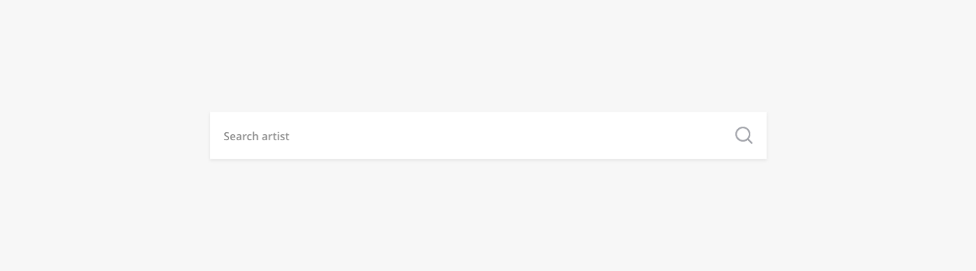

* KT-DD-SearchResults-01

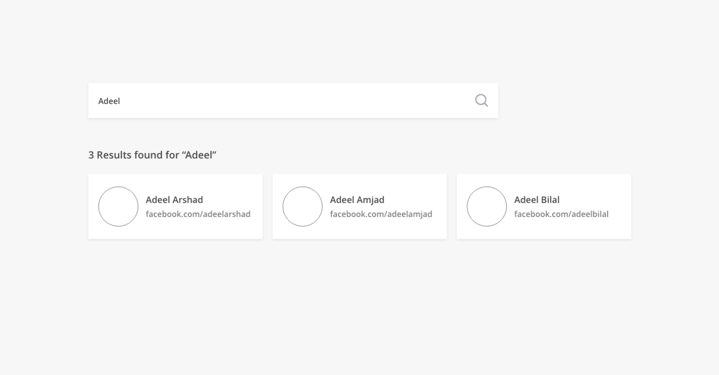

* KT-DD-Eventlisting-01

